**Virtual machine**

1. Experiment-1:Create a Simple Web Application using Java or Python and host it in any Public Cloud Service Provider (Azure/GCP/AWS) to demonstrate Platform as a Service (PaaS).

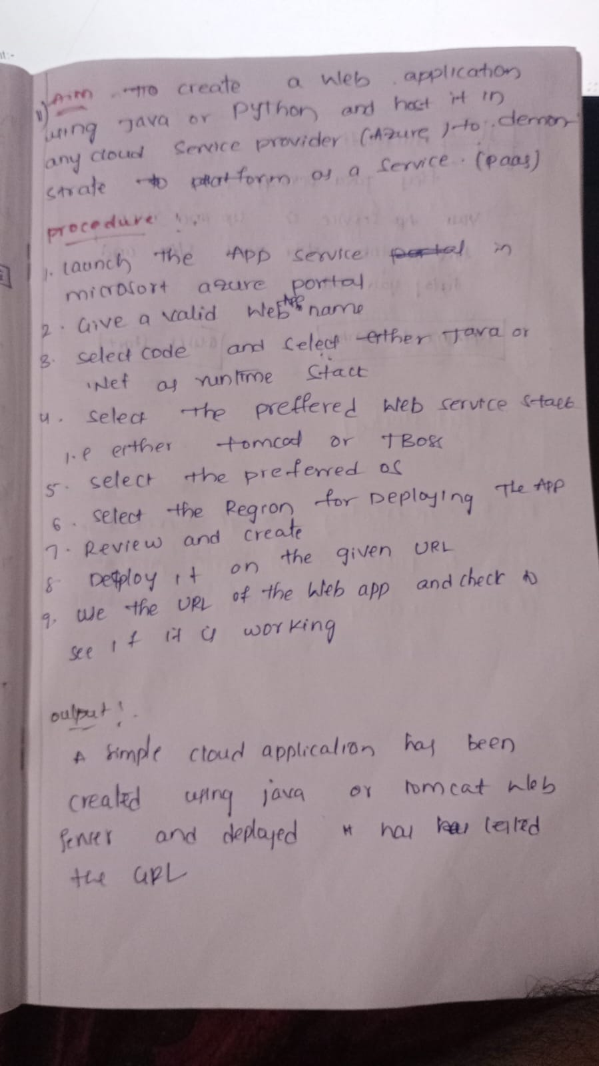

Output:-

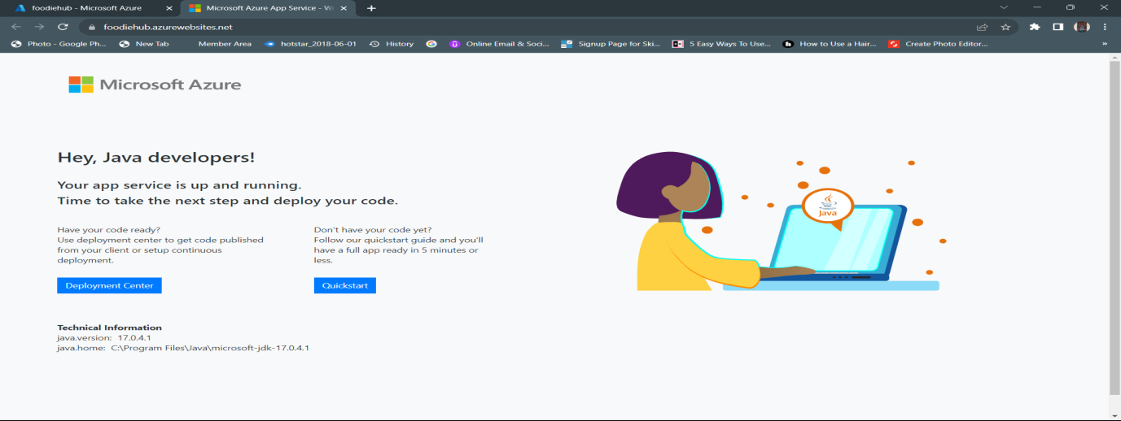

1. Experiment-2:Demonstrate Platform as a Service (PaaS) create and configure a new VM Image in any Public Cloud Service Provider

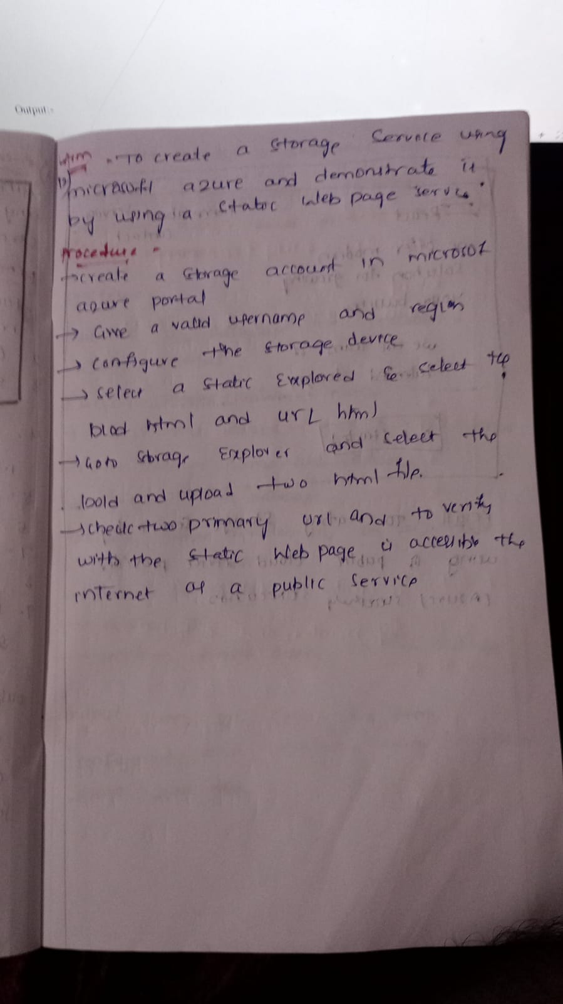

Out put:-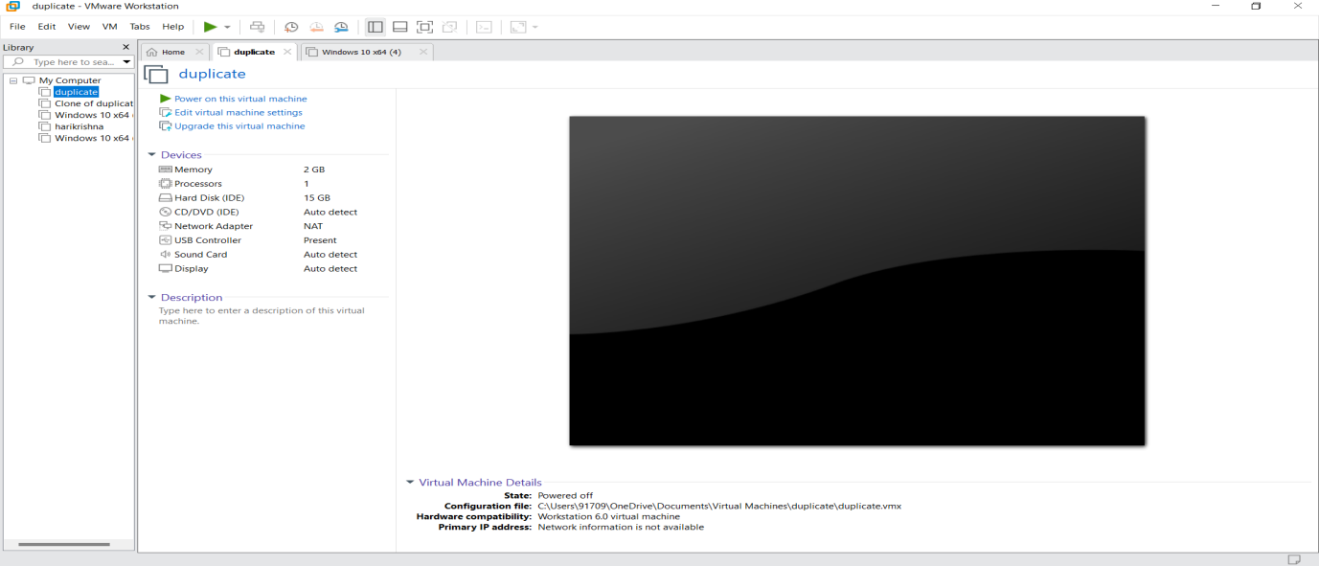

Experiment-3: Create a Storage service using any Public Cloud Service Provider (Azure/GCP/AWS) and check the public accessibility of the stored file to demonstrate Storage as a Service.

Output:-

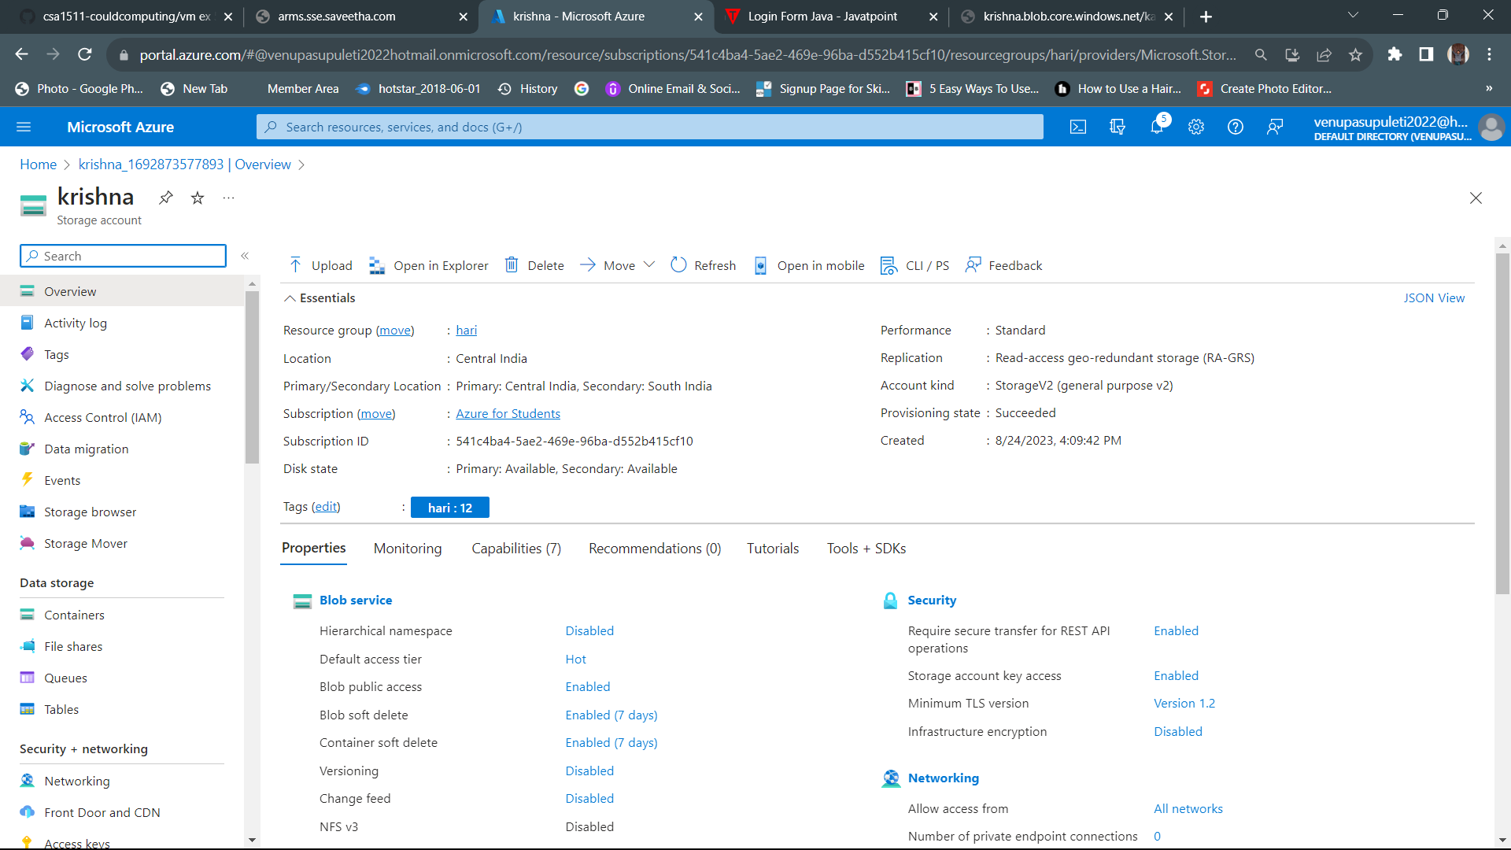

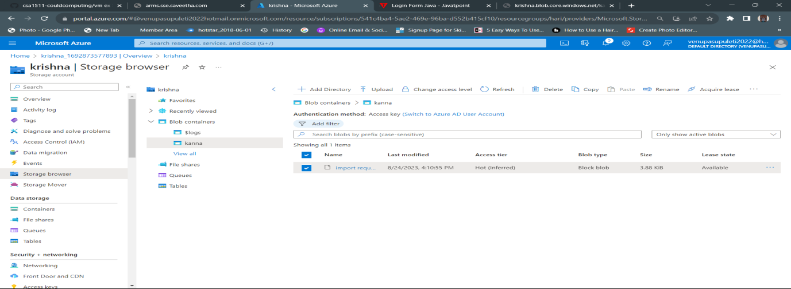

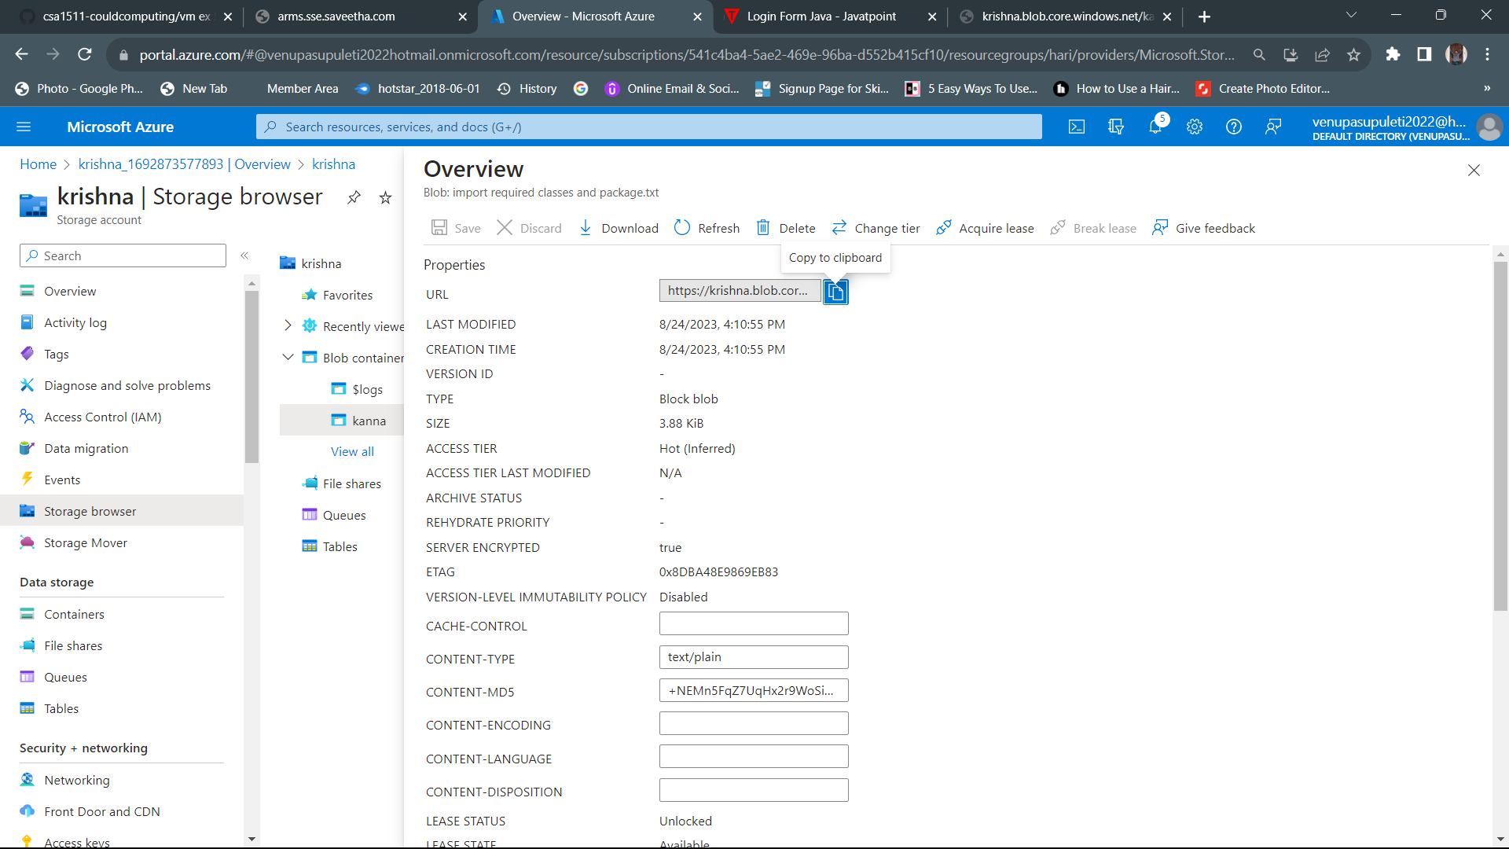

1. Experiment-4:Database as a Service (DaaS) create and configure a new VM Image in any Public Cloud Service Provider

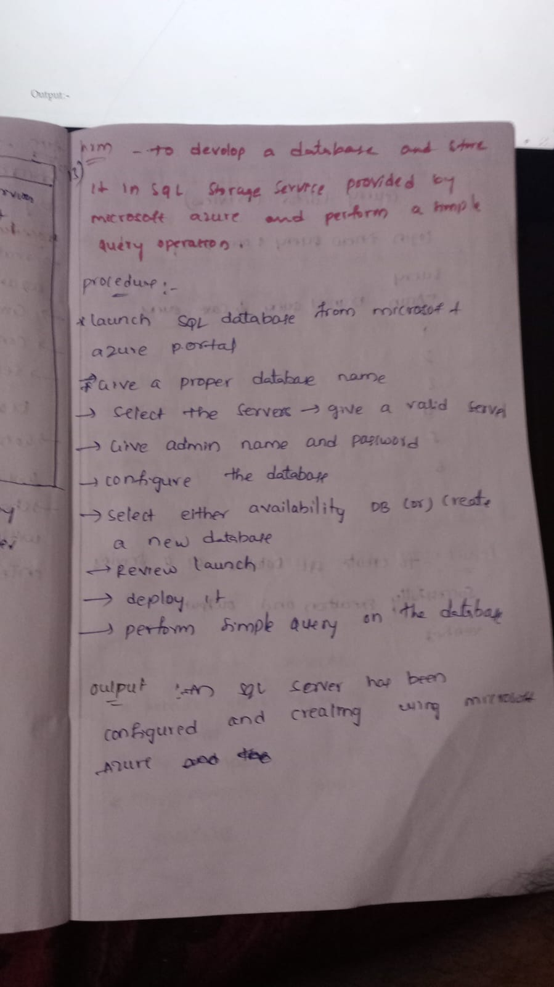

Output:-

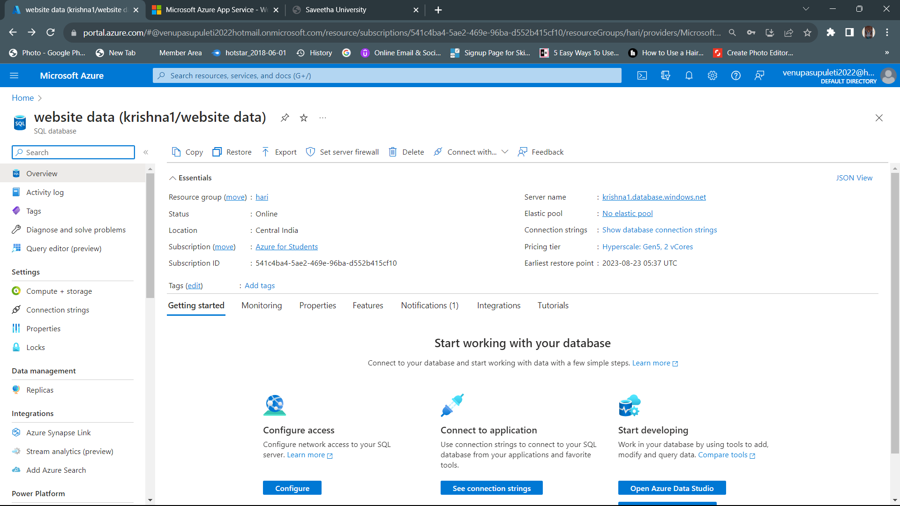

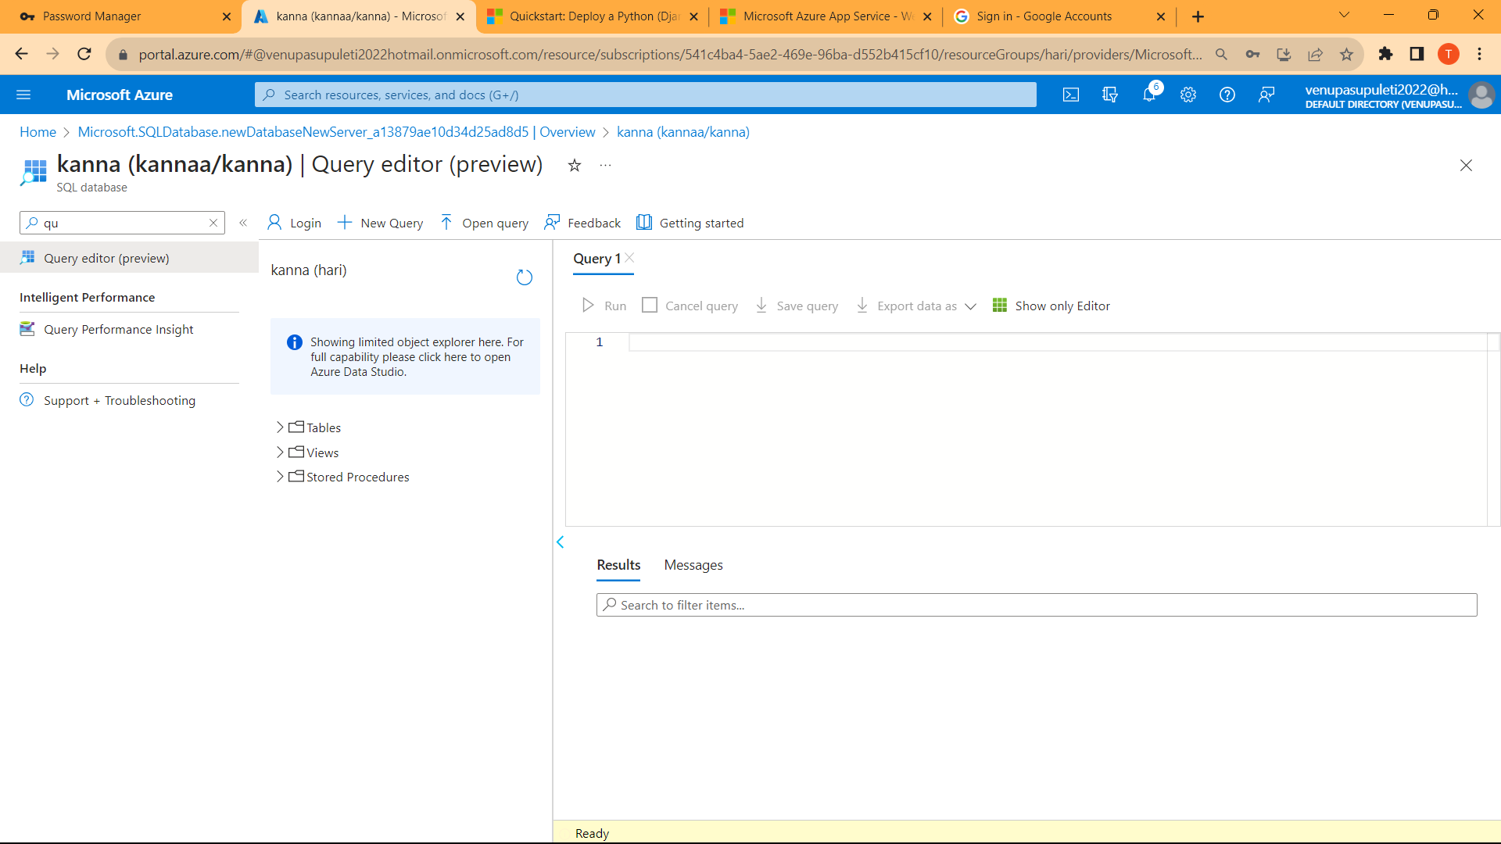

1. Experiment-5: Create a SQL storage service and perform a basic query using any Public Cloud Service Provider (Azure/GCP/AWS) to demonstrate Database as a Service (DaaS)

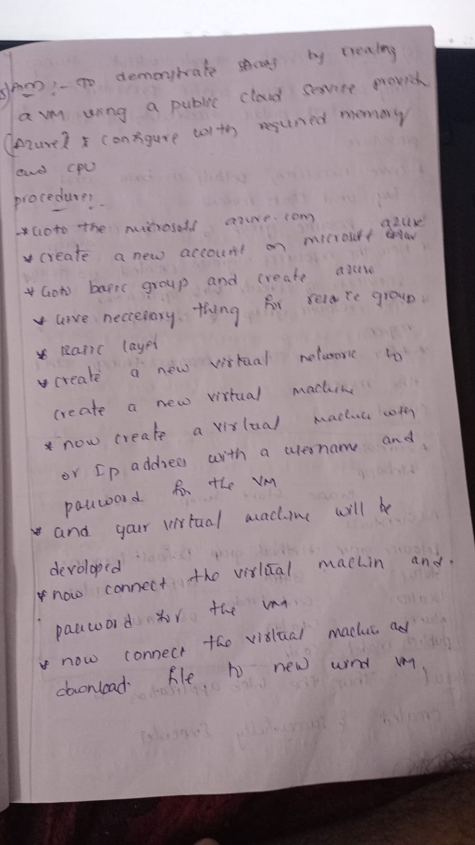

Output:-

